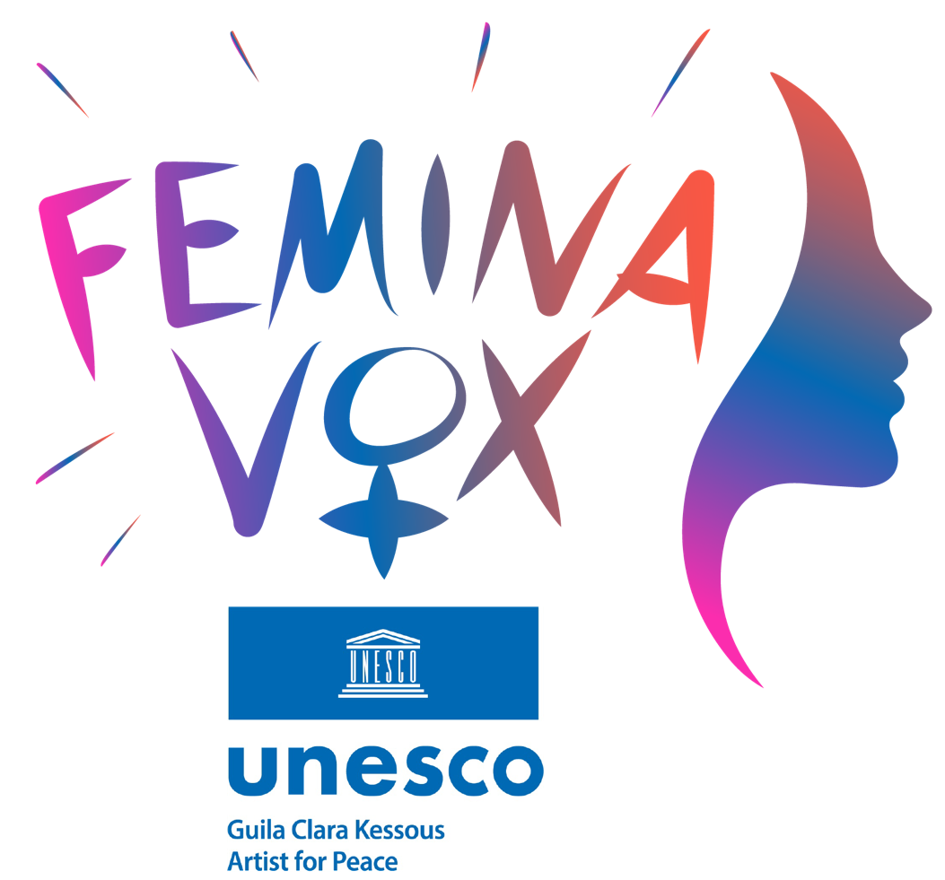 [**Femina Vox International Forum 5th Edition**](http://www.feminavoxforum.com/)

**Voices for women’s rights 2025**

**MAKING WOMEN’S VOICES HEARD**

**PEACE, EDUCATION AND SOCIAL JUSTICE**

**Created and Directed by Dr Guila Clara Kessous,**

**UNESCO Artist for Peace & Peace Ambassador from the Universal Circle of Peace Ambassadors (Geneva)**

**Wednesday 5 March 2025**

**3.00 pm – 6.00 pm CET (Paris time)**

**UNESCO’s Headquarters, Room I**

**Celebrating 30th anniversary of Beijing Declaration**

*The Femina Vox International Forum provides a global platform for women's voices across all sectors of society, allowing them to express their struggles, successes, and aspirations. Because gender equality is still far from being achieved, and every voice matters in advancing women's rights worldwide, more than twenty speakers will share their experiences and propose concrete solutions to drive change at their level. More information:* [www.feminavoxforum.com](http://www.feminavoxforum.com)

*“In 1995, in Beijing, the international community adopted the UN Declaration and Platform for Action for women’s rights. Since then, significant progress has been made in the field of education. This momentum must continue because gender equality in education is not yet a reality.”*

**Audrey Azoulay** UNESCO Director-General

*“Women need to have access to the same rights as men, not as women, but as human beings. The recognition of those women’s rights will only be achieved together in a side-by-side fight, men and women united to finally build the society of tomorrow”*

**Dr Guila Clara Kessous**

UNESCO Artist for Peace – Ambassador for Peace of the Universal Circle of Ambassadors of Peace (Geneva)

**REGISTRATION**

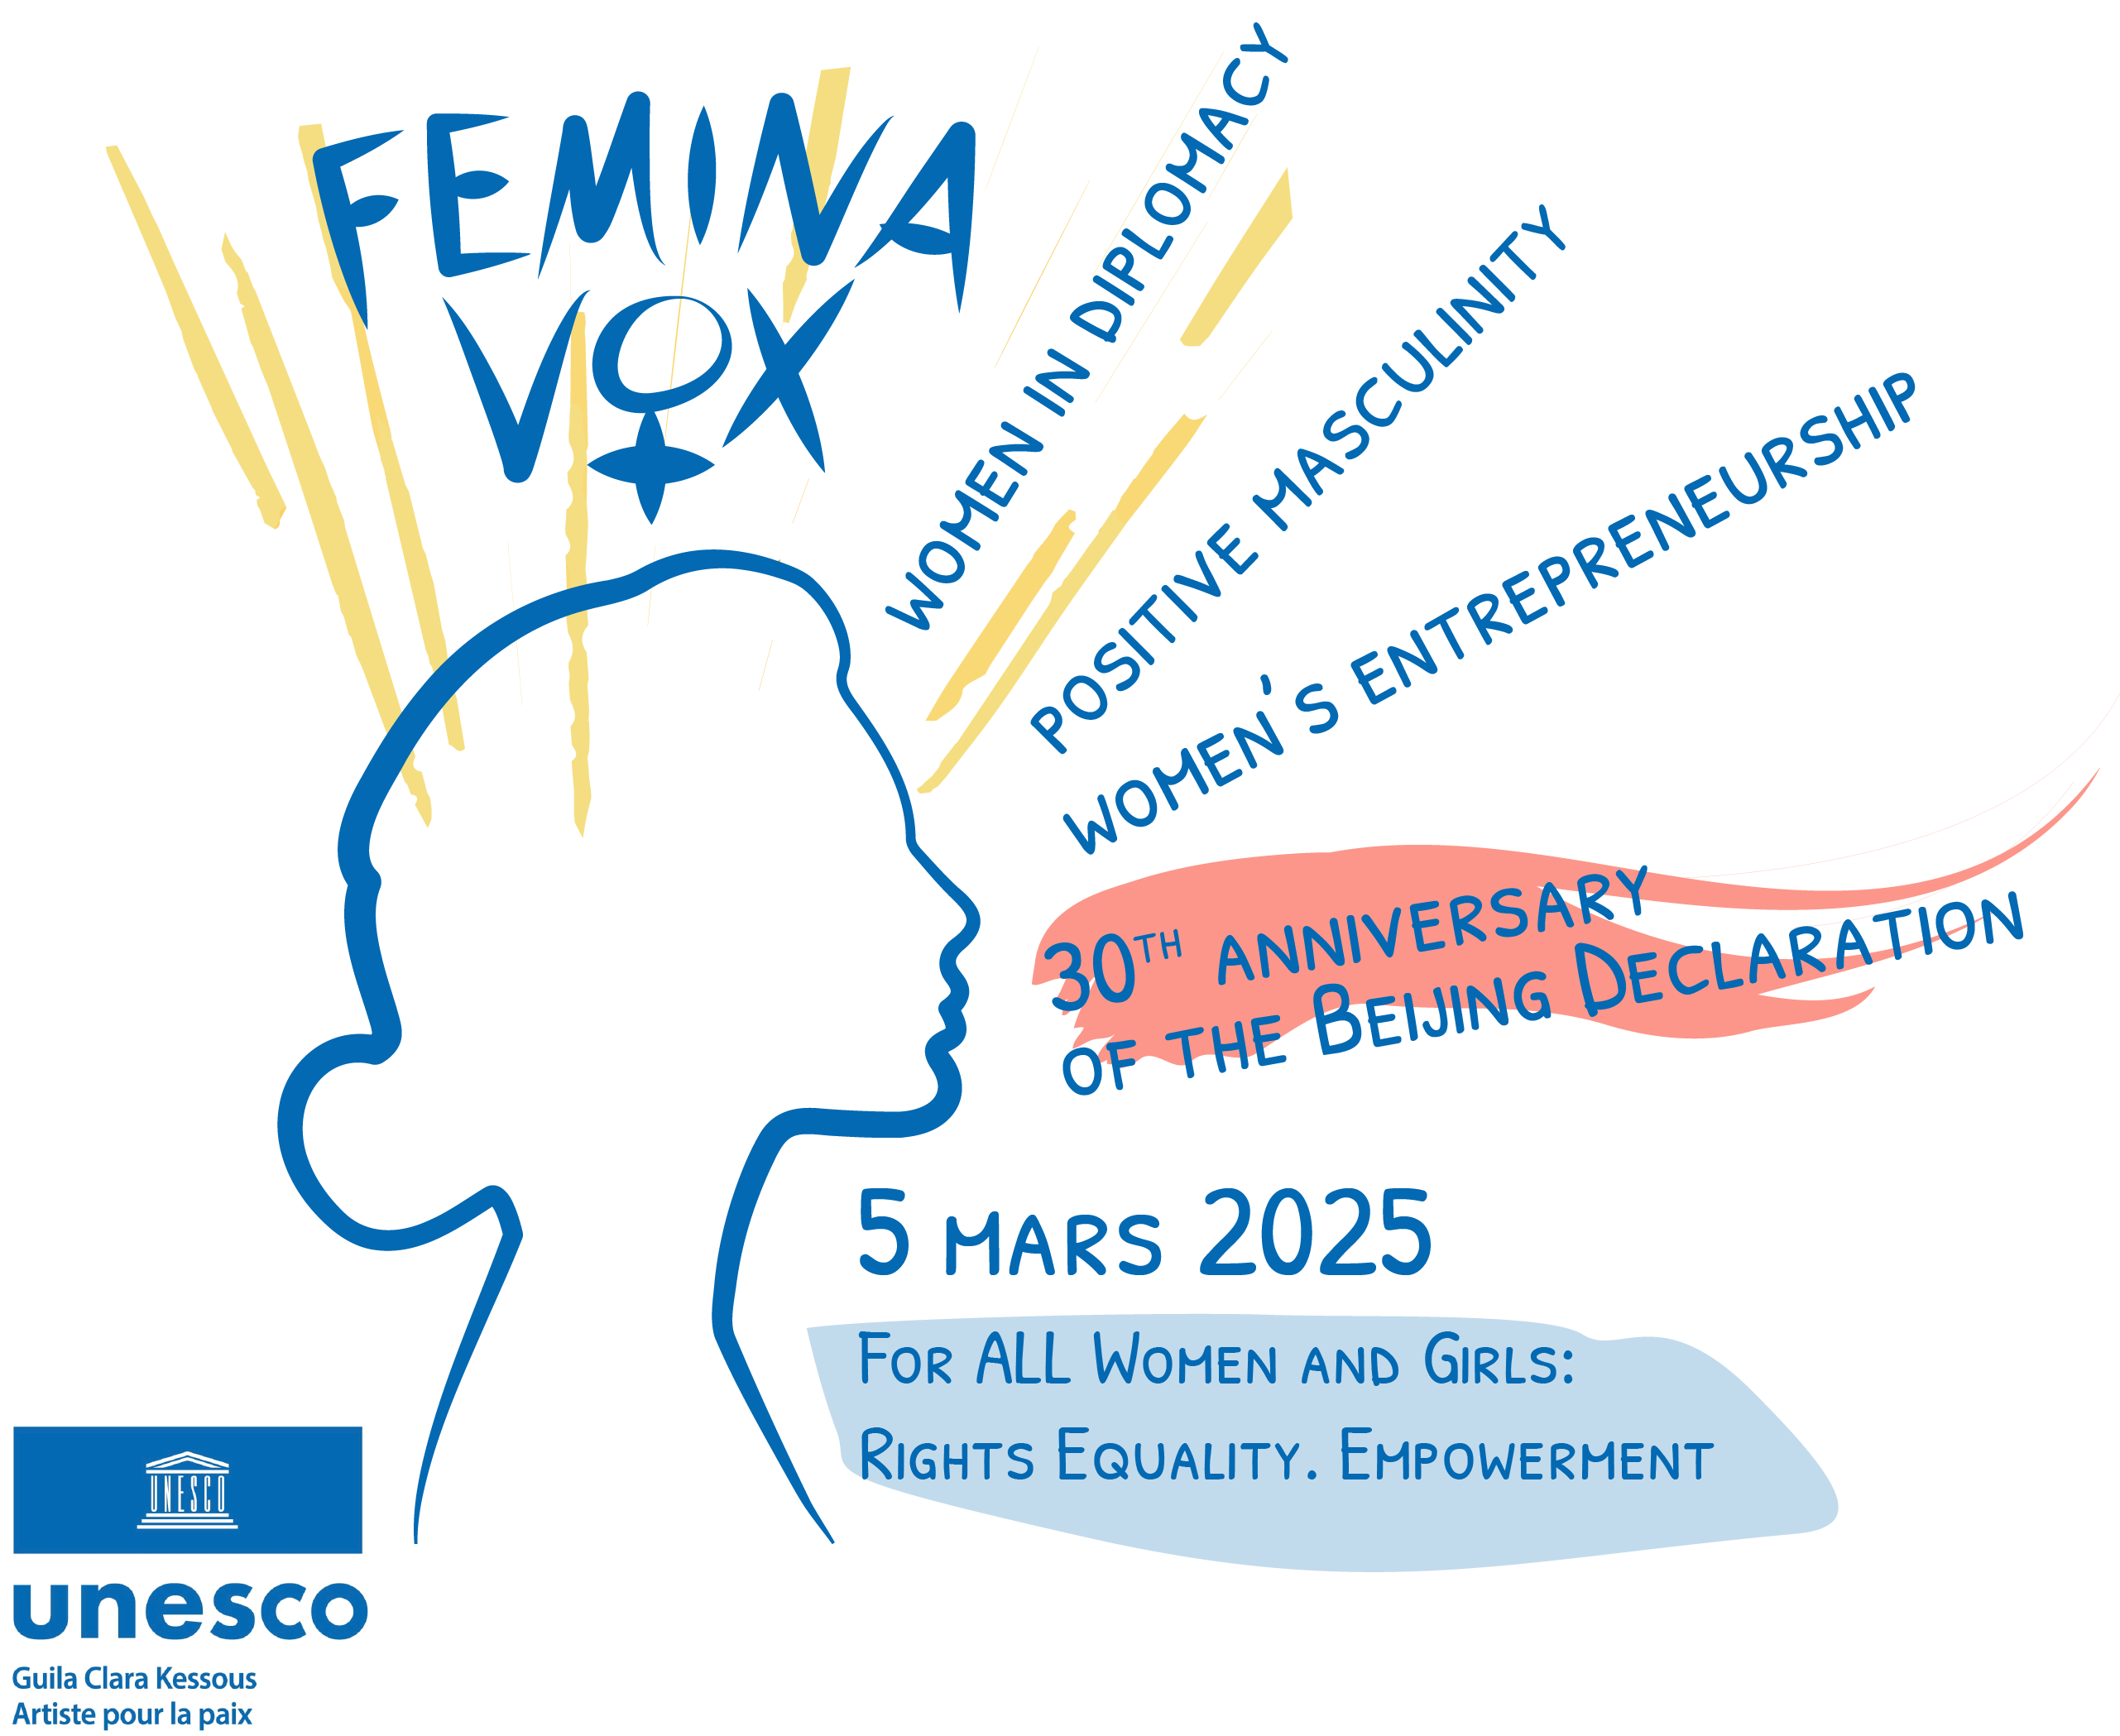

[**Femina Vox International Forum 5th Edition**](http://www.feminavoxforum.com/)

**Voices for women’s rights 2025**

**MAKING WOMEN’S VOICES HEARD**

**PEACE, EDUCATION AND SOCIAL JUSTICE**

**Created and Directed by**

**Dr Guila Clara Kessous,**

**UNESCO Artist for Peace & Peace Ambassador from the Universal Circle of Peace Ambassadors (Geneva)**

**Wednesday 5 March 2025**

**3.00 pm – 6.00 pm CET (Paris time)**

**UNESCO’s Headquarters, Room I**

**PROGRAM**

**3:00 pm – Opening**

3:00 pm – Opening Speech by **Dr. Guila Clara Kessous,** UNESCO Artist for Peace & Peace Ambassador, Director of Femina Vox International Forum

3:10 pm – Artistic Performance - Dancer **Mrs Qian Qu** (China)

3:20 pm – Roundtable no.1: **Celebrating the 30th anniversary of the Beijing Declaration**

* *A signature roundtable featuring high-profile women leaders reminding the importance of the Beijing Declaration*
* *Focus on the Platform for Action to better understand the resonance of today’s responsibility towards women empowerment*
* **Mrs. Wang Yanping,** Beijing 95th Women’s Conference (China)
* **Mrs. Wang Xiangxian,** All-China Women’s Federation (China)
* **Mrs. Yvonne Yung Hun,** actress and former beauty queen (China)

3:55 pm –Artistic Performance – **The Mammas from Congo**

4:00 pm – Roundtable no.2: **Women in diplomacy**

* *High-level roundtable featuring women political leaders to understand better women empowerment in diplomacy*
* *Focus on the achievements, challenges, and future of women in international relations and diplomacy*
* **Her Royal Highness Princess Sohila Al Faisal Al Saud (**Saudi Arabia)
* **Mrs. Chantal Chambu Mwavita**, Minister for Human Rights (Democratic Republic of the Congo)
* **Honorable Wanu Hafidh Ameir**, Deputy of the Tanzanian government and President of Mwanamke Initiatives Foundation (Tanzania)

4:40 pm –Artistic Performance – **Singer Mrs. Hura Mirshekari** (Iran)

4:45 pm – Roundtable no.3: **Women’s entrepreneurship**

* *A roundtable presenting women’s rights today and the continual fight for equality with grounded solutions in the most challenging situations*
* *Far from victimization, this roundtable present entrepreneurship of women who are working for freedom for basic rights in desperate situations.*
* **Mrs. Amida Haman,** Director of Radio Begum (Afghanistan)
* **Mrs. Shayda Hessami,** NGO Humanitarian Help and Journalism in Middle East(France/Iran)
* **Mrs. Golshifteh Farahni,** actress (Iran)

5:15 pm–Artistic Performance: **The Asian Women Choir** (Bangladesh)

5:20 pm – Roundtable no.4: **Transforming MEN’talities for positive masculinities**

* *A roundtable celebrating male allies who actively promote gender equality.*
* *Presenting definitions of “positive masculinity”*
* **Mr. David G. Smith,** Johns Hopkins Carey Business School (USA)
* **Mr. Mathieu Narendra**, Founder “Alternatives”, Young Leader French African Foundation (Madagascar)
* **Mr. Siyabulela Jentile,** Founder “Not in my name international”, “Mandela Washington Fellowship for Young African Leaders” (South Africa)

**5:50 pm – Closing**

5.50 pm – Wrap up by Dr. **Guila Clara Kessous,** UNESCO Artist for Peace & Peace Ambassador, Director of Femina Vox International Forum

5.55 pm – Artistic Performance - Singer **Mrs. Joyce Jonathan** (France)

5.50 pm – Wrap up by **Guila Clara Kessous,** UNESCO Artist for Peace & Peace Ambassador, Director of Femina Vox International Forum

5.55 pm – Artistic Performance: **Joyce Jonathan** (France)

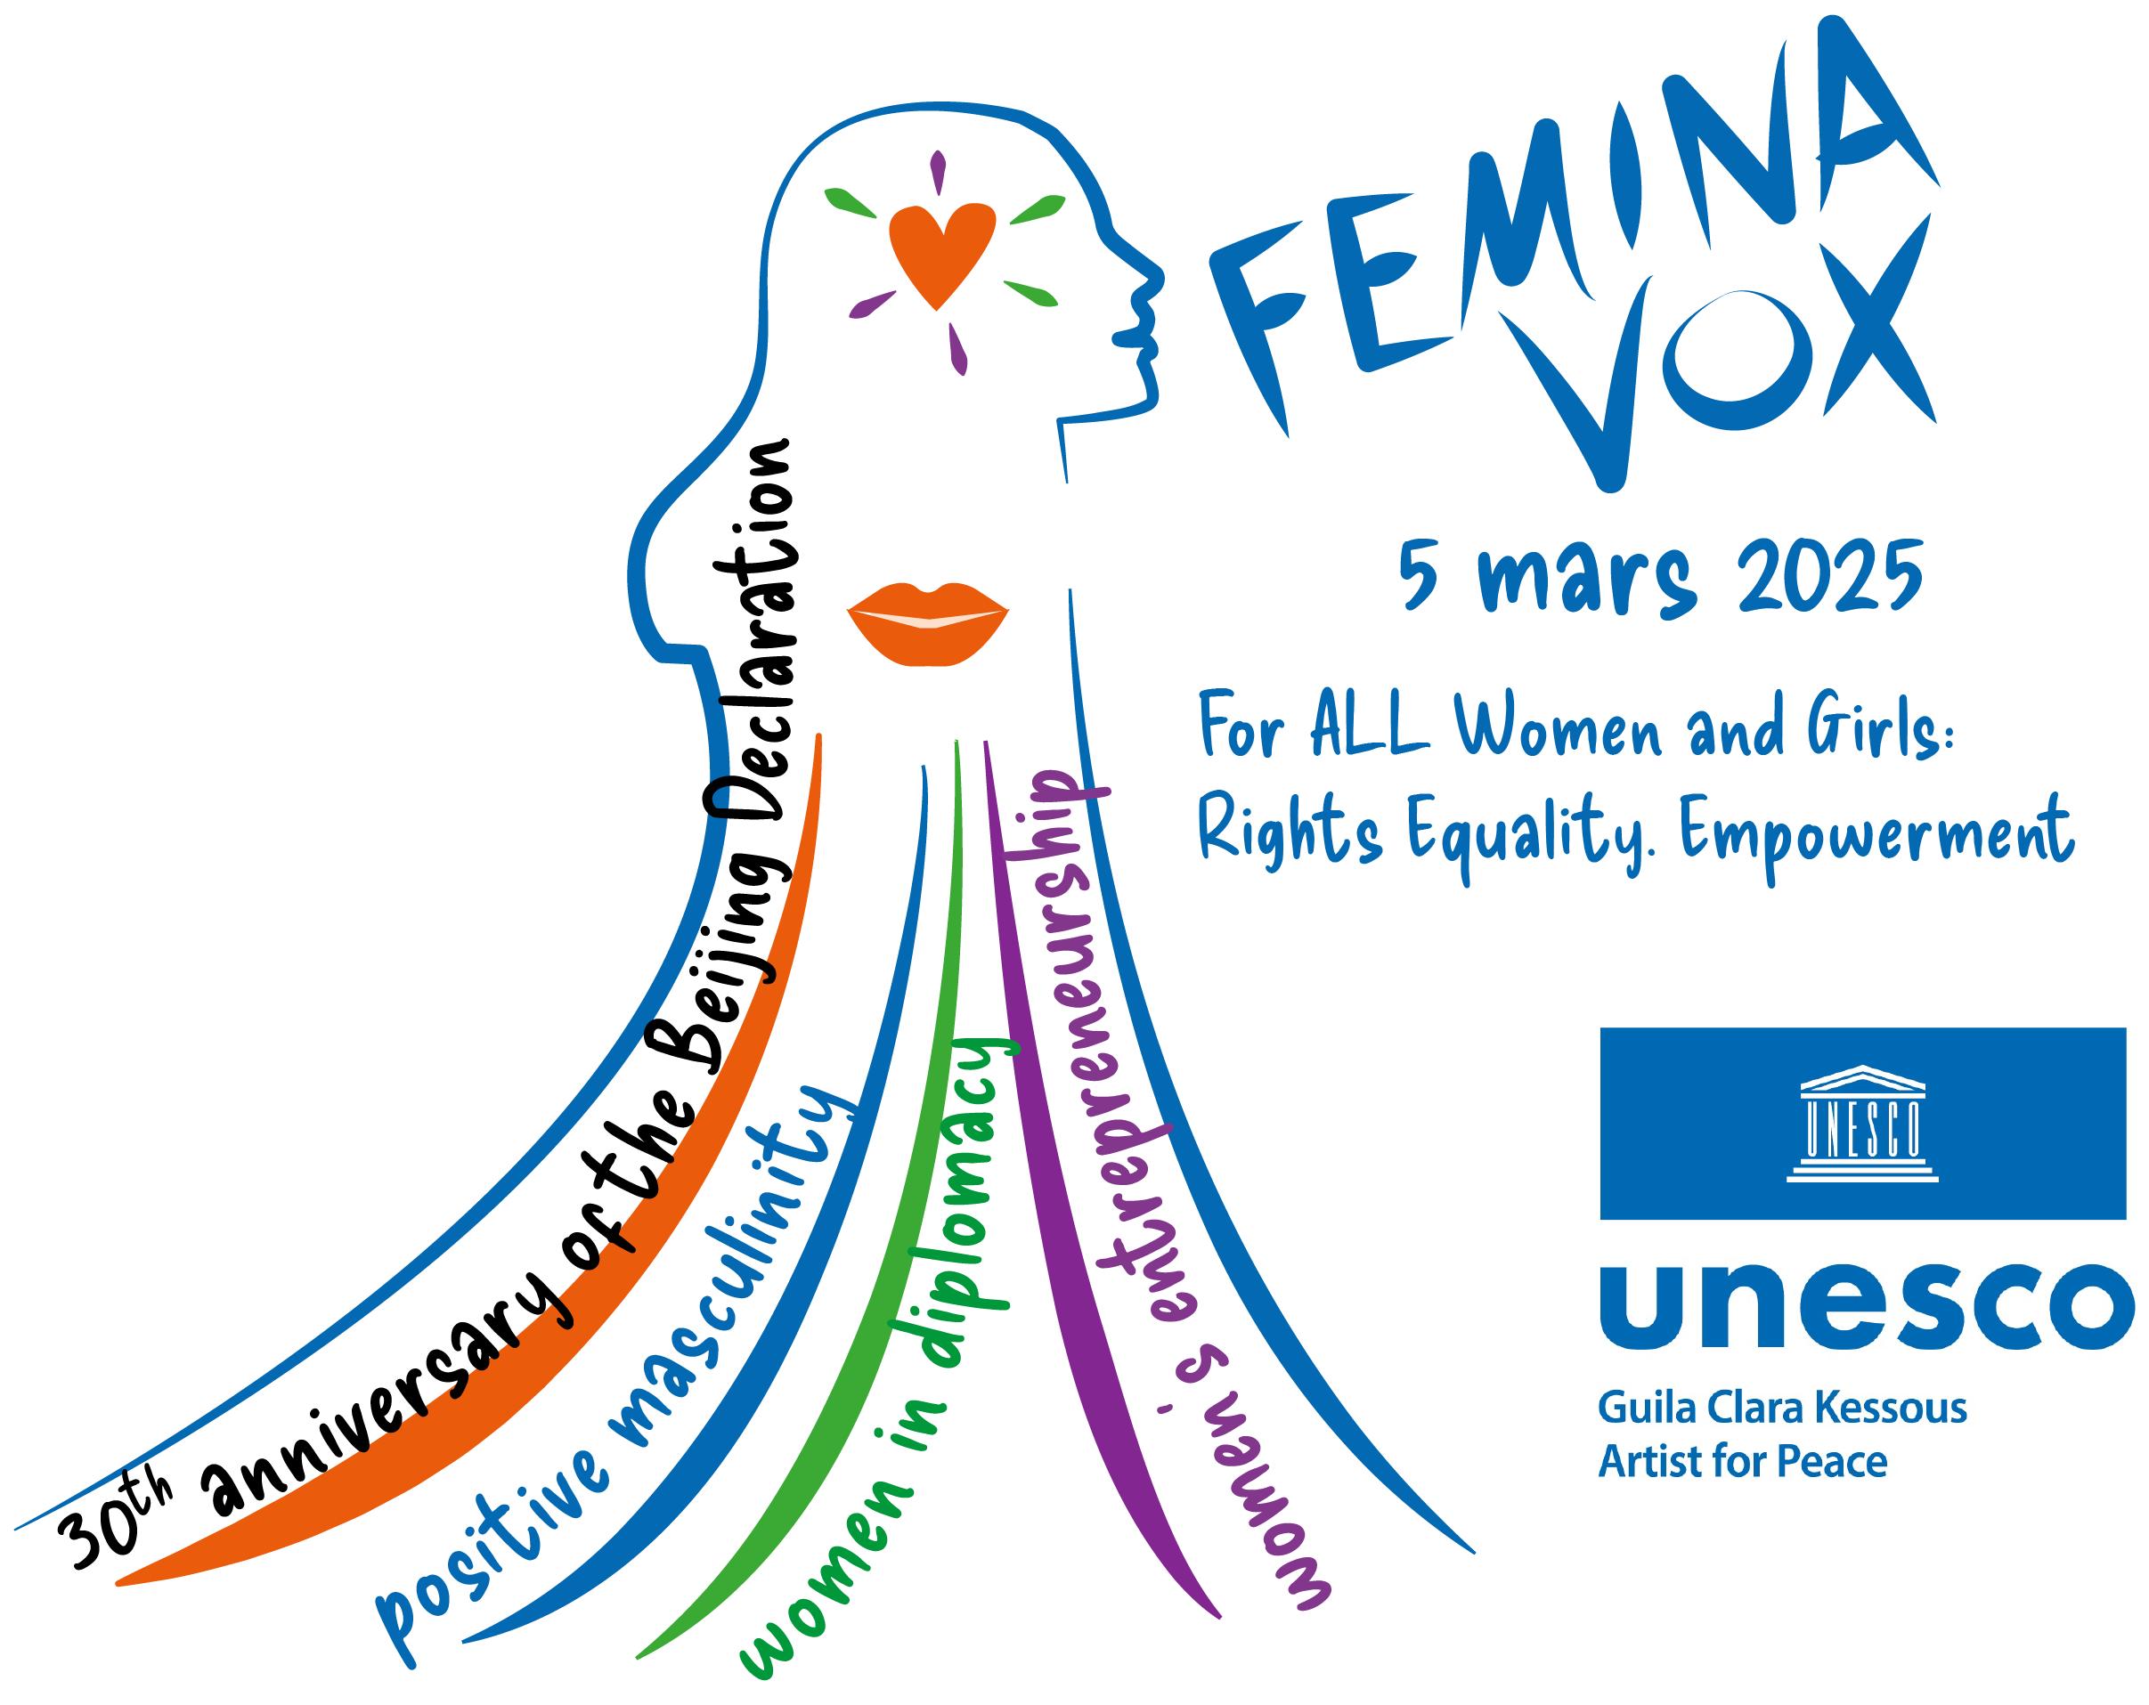***Over 150 prominent figures have already spoken as part of Femina Vox International Forum such as:***

[***Dr. Denis Mukwege –*** *Congolese gynecologist, 2018 Nobel Peace Prize laureate*](https://www.youtube.com/watch?v=WNjVfF9iMfc&t=2s)

[***Dr. Shirin Ebadi –*** *Iranian lawyer, 2003 Nobel Peace Prize laureate*](https://www.youtube.com/watch?v=PrgsSMVvrk8)

[***Federico Mayor –*** *Former Director-General of UNESCO*](https://www.youtube.com/watch?v=hv9UujdRIIo)

[***Claudia Cardinale –*** actress, activist and founder of the Fondazione Claudia Cardinale](https://www.youtube.com/watch?v=a-o1V-EqI3M)

[***Her Royal Highness Maria Teresa Mestre –*** *Grand Duchess of Luxembourg*](https://www.youtube.com/watch?v=KdSK9z__Qso&list=PLAPXcMZFT_YAv-tnPK5Uz2jOXsIVGnJIp&index=3)

[***Eve Ensler –*** *American playwright, author of The Vagina Monologues*](https://www.youtube.com/watch?v=qbolDkrO-ho)

[***Boris Cyrulnik –*** *French neuropsychiatrist, specialist in resilience*](https://www.youtube.com/watch?v=1j3miUDniso)

[***Diane von Fürstenberg –*** *Philanthropist and fashion designer*](https://www.youtube.com/watch?v=iY_HzZj_Xsg&list=PLAPXcMZFT_YAv-tnPK5Uz2jOXsIVGnJIp&index=6)

[***Lisa Yasko –*** *Ukrainian Member of Parliament*](https://www.youtube.com/watch?v=iUXdsw00BQ0)

[***Amma - I****ndian spiritual leader Her Holiness Sri Mātā Amritānandamayī Devi*](https://www.youtube.com/watch?v=8g4olze6ha8&t=11s)

[***Her Excellency Eliza Jean Reid –*** *First Lady of Iceland*](https://www.youtube.com/watch?v=g9latLBiRcY)

[***Her Excellency Mareva Grabowski Mitsotakis –*** *First Lady of Greece*](https://www.youtube.com/watch?v=LJv9wmT9u4o)

[***Her Excellency Arya Ali –*** *First Lady of Guyana*](https://www.youtube.com/watch?v=sLB50gTM9z8)